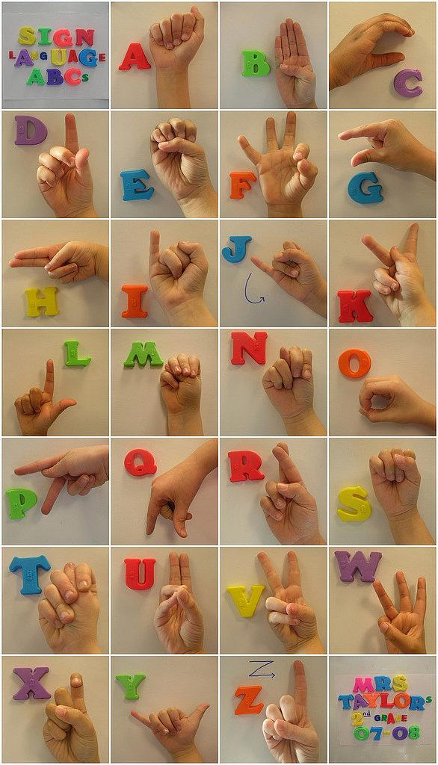

Practice your Letterland Words by signing the letters.